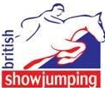 North Cumbria Area 14 

Area Training
The first area training of 2017 will take place indoors at Greenlands Equestrian Centre, Wreay on Tuesday 28th February with popular BS UKCC level 3 accredited coach Tracey Newman.
Lessons are £27.50 each for BS members or £30.00 for non BS members. Lessons are based on groups of three sharing for one hour and 15 minutes.
To book please call or message Michelle Byrne on 07903 031405
Payment to be made via Horse Monkey please https://horsemonkey.com/search_events
All lessons must be booked and paid for in advance.
Cancelled lessons will still be charged unless the lesson can be filled.

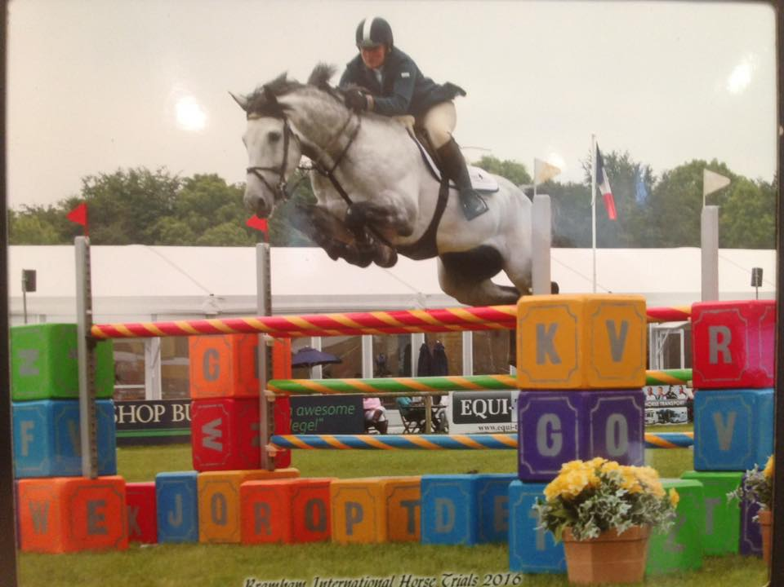

Jonathan Dixon on winning form at Aintree Equestrian Elite Show
Well done to Jonathan and Joanne Dixon who had a very successful show at the Aintree Equestrian Elite show last weekend. With numerous placings over the three days Jonathan finished the show with a first and third in the highly competitive 1.30m class with Camona and Centa Bella.

Area 14 AGM
The North Cumbria (14) British Showjumping Area Annual General Meeting will take place at 7.00pm on Monday, 20th February 2017 at Club Britannia, 35 Lowther Street, Carlisle, CA3 8EJ. For further details please contact Richard Jenkinson (Area Representative) – 07876 254090 or email: richard.jenkinson@awjenkinson.co.uk
This is your opportunity to let us know your ideas and to hear what is planned for the area going forward.
We look forward to seeing you there.
www.britishshowjumping.co.uk/area/North-Cumbria
Don’t forget to check out our area face book page Area 14 North Cumbria British Showjumping

